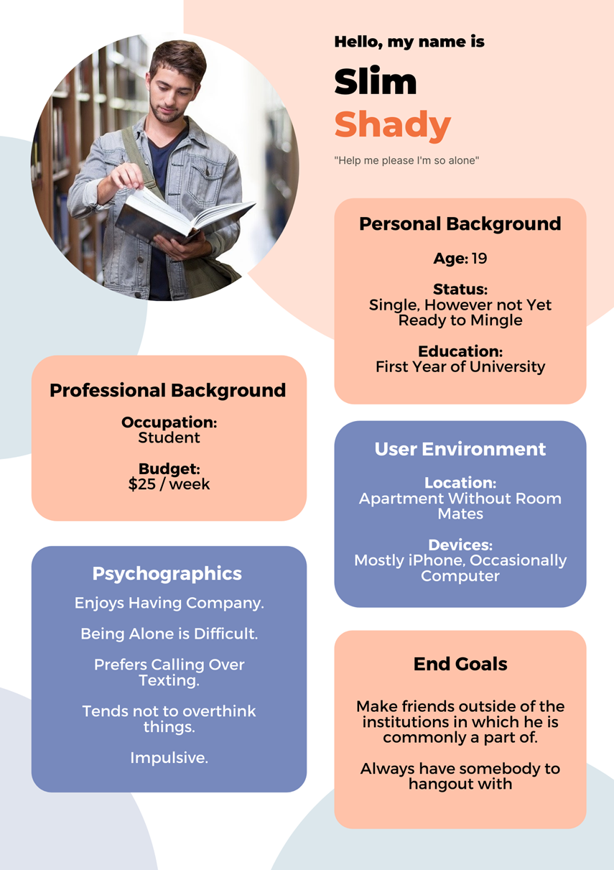

**Needs and wants**

Betty would love to be in control of her own thoughts without being afraid she will say someone inappropriate or is not able to recall something because of her dementia. She is willing to try any tool that will support her with managing her dementia as good as possible.

**Personality**

Betty is a very social person who loves to talk to anyone she walks into. She sees the good in every situation and is always as positive as she possibly can. Sometimes, she feels lonely when no one is able to visit her. Sometimes, she struggles with the consequences of her dementia, such as lacking the ability to match face with name more and more. Then, she can feel emotional.

**Biography**

Betty has raised two children. She loves to take a walk in the park nearby. Betty is a traveler and has seen many places in the world. She loves to spend time with her children and grandchildren.

**Betty**

**Health**

Betty suffers from stage 3 of dementia. She has problems with concentrating and starts to forget more and more over time. She is taken care off very well by close ones her and is safe in the home she lives in.

**Age:** 75

**Place of Living:** Eindhoven, The Netherlands

**Home Situation:** Widow, lives in an apartment

**Profession:** Teacher

**Diagnosis:** Dementia